**Worksheet 1.3**

**Student Name:** Sahil Kaundal **UID:** 21BCS8197

**Branch:** CSE (Lateral Entry) **Section/Group:** 20BCS-807_B

**Semester:** 4th  **Date of Performance:** 11/03/2022

**Subject Name:** Computer NetworksLab **Subject Code:** 20CSP-257

**1. Aim/Overview of the practical:**

Create a network connection using packet tracer, which shows the working of Switch and Hub. Explain in detail with proper steps.

**2. Task to be done/ Which logistics used:**

Create a network connection using packet tracer, which shows the working of Switch and Hub.

**3. Steps for experiment/practical/Code:**

* Attach required devices (Hub/Switch/Router) in the packet tracer software.
* Assign IP address to devices.
* Select source and destination and drop packet from source to destination.
* Go to Simulation mode and click capture/Play.
* Simulation will start and packet will only be accepted by destination.

**4. Result/Output/Writing Summary:**

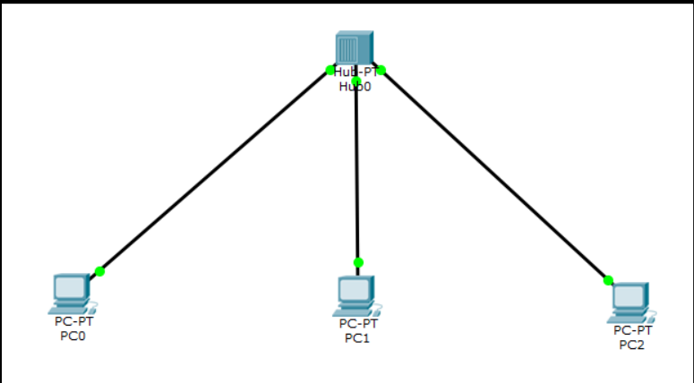

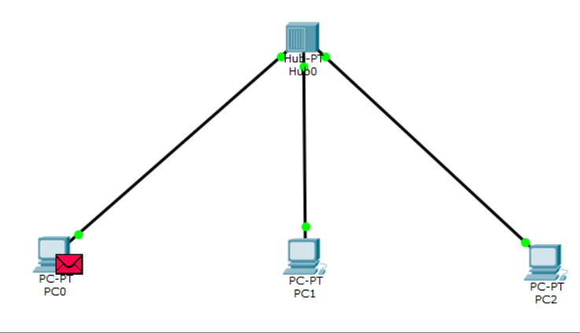

**Simulation:**

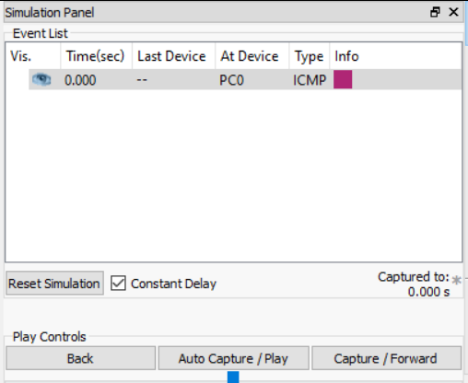

**Outcome:** 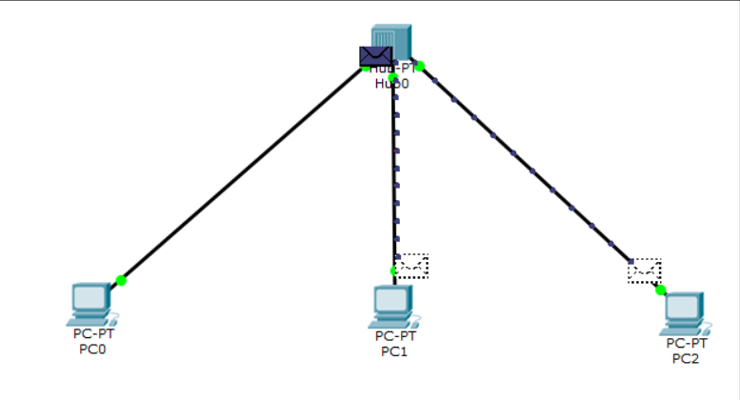

I have successfully completed this experiment.

**Learning outcomes (What I have learnt):**

1. Using Cisco Packet Tracer.
2. Creating network connection using packet tracer.

**Evaluation Grid (To be created as per the SOP and Assessment guidelines by the faculty):**

|  |  |  |  |
| --- | --- | --- | --- |
| Sr. No. | Parameters | Marks Obtained | Maximum Marks |
| 1. |  |  |  |
| 2. |  |  |  |
| 3. |  |  |  |
|  |  |  |  |